New issue of the Friedhelm Loh Group “be top” magazine
AI momentum –
be top magazine showcases opportunities for industry
Herborn, 2025-12-1
AI is everywhere. The opportunities are huge, including for industry – provided the new AI technologies from the digital economy can be combined with know-how from industry. The new issue of be top demonstrates exactly how this can be achieved. Containing articles about specific use cases and new technologies, along with fascinating insights from AI experts, the Friedhelm Loh Group’s company magazine spells out how industry and the digital economy can benefit from the latest technologies.
This year’s second issue embarks on a major new chapter with AI. The be top cover story assesses studies by Boston, McKinsey, Deloitte and other analysts. Besides business prospects, it also considers the role played by AI agents and AI-ready data. This assessment clearly shows that AI will take the lead in developing technologies for the future, and that German industry can keep its nose in front thanks to its extensive data know-how. That’s not all, though. Industry and the digital economy actually have a double opportunity. The cover story concludes that DeepTech with AI to speed things up is a highly relevant lever for new growth curves.
AI is revolutionising engineering

A use case involving the Eplan Copilot, which was developed based on Microsoft Azure OpenAI Service, shows how AI is revolutionising sectors such as electrical engineering. The Copilot uses existing data to complete 3D designs of enclosures and mounting plate layouts in a matter of seconds. Other fascinating content on this topic includes the insights provided in an interview with Rainer Brehm, CEO of Siemens Factory Automation, and Sebastian Seitz, CEO of Eplan. The Siemens Industrial Copilot and the Eplan Copilot are already collaborating, in the form of communication between AI agents via APIs.

New cooling concepts for AI factories

A look behind the scenes reveals another aspect of AI momentum. In his guest article, Meta engineer Steve Mills highlights how AI is changing the design of data centres as a result of increasing computing power and speeds. Future IT infrastructures will feature direct current power supplies and liquid-based cooling concepts. Rittal is already demonstrating how to operate AI infrastructure with direct liquid cooling at the GSI Helmholtzzentrum für Schwerionenforschung in Darmstadt, where direct chip cooling with water is generating a cooling output of 1 MW in the tightest of spaces.

Customer success on the energy market
The latest issue of be top also demonstrates how Friedhelm Loh Group customers can use original, ingenious solutions to meet the challenges of the energy market. Utility company ELE Verteilnetz GmbH (EVNG), for instance, has boosted the self-sufficiency of its supply network thanks to a modular system incorporating a concept, hardware and software from Rittal and Bechtle.
Industrial automation and switchgear manufacturing specialist gefeba investigated how the new RiLineX busbar platform can save a great deal of time. In a field study conducted under the independent supervision of the Fraunhofer Institute for Material Flow and Logistics IML, assembly processes were found to be 75 percent faster.
Another attention grabber is the incredible tale of siblings Caroline and Christian Trips, who transformed the business their parents originally founded with just five people into a successful system house for automation solutions. Their company uses software and hardware from Eplan, Rittal and Rittal Automation Systems, including at the plant it recently opened in Poland. Strategic thinking focused on the energy market and genuine partnerships held the key to success.
Further customer applications covered in the latest issue include:
- Pezag (Switzerland): An equipment manufacturer is saving space with outdoor enclosures from Rittal
- SGAC (China): Setting new standards in smart manufacturing with Eplan, Rittal and Rittal Automation Systems
- Mosaico Group (Italy): Systematic automation in plant engineering with Eplan, Rittal and Rittal Automation Systems
- Frankfurt Airport: A new Rittal data centre in the Baggage Control Center
- GEA: Automating a centrifuge with Eplan, Rittal and Rockwell Automation
- Tetrapak and eBeam: Cideon connector is networking CAD data from SolidWorks PDM with the SAP S/4HANA Public Cloud

Dealing with risks in the steel industry

be top also addresses the challenges facing the steel industry.. Automotive manufacturing is in the midst of a revolution, and Stahlo is right at the heart of things. As an independent steel service centre, the company acts as an interface between steel producers, automobile manufacturers, and their suppliers. Benedict Raspovic, Head of Key Account Management Automotive at Stahlo, explains how the major challenges of our times are changing the discussion agenda – and how Stahlo is making it easier for customers to navigate the industry with its Steel Compass.

Commitment to people
The Friedhelm Loh Group has a long tradition of supporting charities. Over the past year, it has donated a total of 200,000 euros to local and global organisations. The new issue of be top also includes articles revealing how the Group’s staff are supporting everything from education in India to food banks in Herborn. The magazine concludes by inviting readers to gain a whole new source of inspiration at the Nationales Automuseum, where exciting projects such as building a wind tunnel are sparking young people’s enthusiasm for technology.

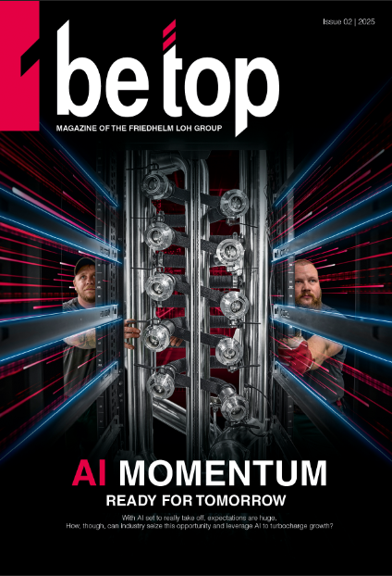
Image 1: The new issue of be top demonstrates exactly how this can be achieved. Containing articles about specific use cases and new technologies, along with fascinating insights from AI experts, the Friedhelm Loh Group’s company magazine spells out how industry and the digital economy can benefit from the latest technologies.

May be reproduced free of charge. Image rights reserved by Friedhelm Loh Group / Rittal GmbH.

Friedhelm Loh Group

The companies of the globally successful Friedhelm Loh Group invent, develop and produce innovative system solutions for industry, IT and energy, as well as other important sectors worldwide. They are among the top addresses in their respective industries.
With their combined hardware and software expertise, Rittal, Rittal Software Systems (Eplan and Cideon) and Rittal Automation Systems (RAS, Ehrt, Alfra) optimize, digitize and automate processes along the entire customer value chain, including the IT infrastructure – from panel building and switchgear manufacturing to mechanical engineering, factory operators and the energy sector. Stahlo and LKH round off the portfolio with end-to-end manufacturing expertise in the modern materials of steel and plastic.
The Group is internationally successful, with 13 production sites and 95 subsidiaries. The family-owned company employs 12,600 people and generated a turnover of 3.1 billion euros in 2024. In 2023, the Friedhelm Loh Group was recognized as a “Best Place to Learn” and “Employer of the Future.
For more information, visit www.friedhelm-loh-group.com.

Corporate Communications
Dr. Carola Hilbrand Friedhelm Loh Group
Corporate & Brand Communications Rudolf-Loh-Straße 1
Phone: 02772/505-2527 35708 Haiger
hilbrand.c@rittal.de www.friedhelm-loh-group.com

