The new issue of the Friedhelm Loh Group magazine is here
Making Europe strong – be top magazine reveals how companies are becoming more competitive
Haiger/Germany, 04 May 2026

European industry is under massive pressure. Cracks are definitely starting to show in the industrial model that has stood the test of time for decades. That makes it all the more important to find new ways of becoming more competitive, and a new drive to succeed. The latest issue of be top shows how European companies are meeting this challenge. The cover story of the Friedhelm Loh Group’s magazine offers some inspiring examples of success. Businesses are leveraging automation, systematic digitalisation and high quality standards to safeguard their competitiveness.

The cover story first takes us to the state-of-the-art Rittal factory in Haiger, in the German state of Hesse. The factory’s clear focus on customers and its high level of automation and digitalisation won it the title “Factory of the Year 2025” – the top award for European production sites. be top highlights how consistently digitalised, end-to-end processes dovetail in Haiger – from the 3D twin at the engineering stage all the way through to delivery. The production of up to 9,000 enclosures each day, AI-supported optimisations and 99.9 percent planning accuracy make the plant a blueprint for a fully automated factory in the heart of Europe.

Faster and better – thanks to digitalisation, quality and efficiency
Examples from Europe show exactly how to boost competitiveness. The Spanish automation engineering and enclosure manufacturing company SIDE is using Eplan and Rittal solutions to reduce machining times for enclosure manufacturing by 80 percent – from around a whole day to approximately 20 minutes.
OREX ROTOMOULDING, a Polish manufacturer of rotomoulding machines for plastic products, has grown from a small business to a market leader in Poland and a global player over the course of just 30 years. Precise machining, high industry standards and international services and certifications are key factors in this success. Liquats Vegetals, the Spanish market leader for plant-based drinks, delivers products to over 45 countries. Its Rittal cooling units achieve energy savings of around 75 percent compared with conventional solutions. To meet high EHEDG hygiene standards and make its production operations sustainable, the beverage manufacturer also uses Hygienic Design enclosures from Rittal.

From best practices to how to turn things around in industry
These and other success stories in be top show what can already be achieved today by harnessing digitalisation and automation. What matters now is realising this potential on a widespread basis. A guest article by Martin Jetter, Chairman of the Board of Directors of the SCION Association and a Friedhelm Loh Group Foundation Council member, explores the conditions that need to be met. The focus is on a new mindset, which is the prerequisite for change.

Further examples illustrate the broad scope of the industrial transformation:
- KlöMö is driving ahead with end-to-end data use and the comprehensive automation of its switchgear manufacturing in collaboration with Eplan, Rittal and Rittal Automation Systems
- RWE is working with Cideon to modernise its software landscape, and is creating a transparent, flexible licence management system
- Voltfang is using outdoor enclosure technology from Rittal for its energy storage systems and getting them ready for the electricity networks of the future
- Greenlyte Carbon Technologies is developing Power-to-X pilot plants for the energy transition with the help of the new Rittal RiLineX power platform
- Viega is using Rittal Micro Data Centers for new IT infrastructures
- Hahn Automation Group has opted for Eplan Cable proD to customise machine cabling at the engineering stage
be top also offers insights into Friedhelm Loh Group innovations that provide a technological edge, including the Eplan Platform 2026 to make engineering more efficient, energy-efficient infrastructure and cooling solutions from Rittal, and automated wire handling in panel building operations.

Competitiveness is a question of talent, too
Qualified specialists will play a key role in the future of industry. In this context, be top reveals how Rittal, Eplan and the renowned Purdue University are working together. The university is collaborating with industrial partners in Germany to offer budding electrical engineers practical, forward-looking training – using software from Eplan as well as hardware and automation solutions from Rittal and Rittal Automation Systems.

A further role model is SchulePlus, which is growing from a regional pilot project into a network spanning the whole of Hesse. Nine out of ten participants already go on to start their apprenticeship at their chosen company, which is a strong indicator of successful career guidance and sustainable talent recruitment.

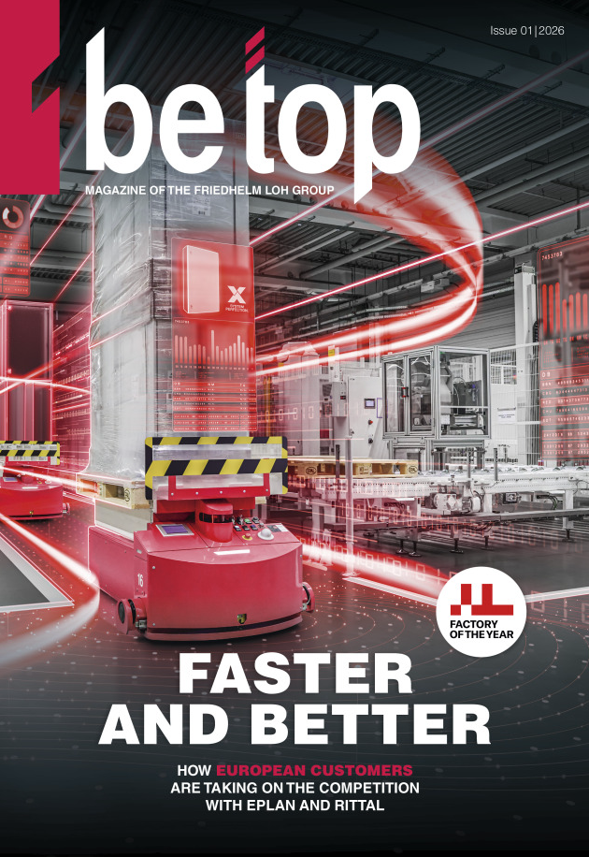
Commitment to people and training
Charitable initiatives and training are further topics covered in be top. The new issue reports on the annual donation by Friedhelm Loh Group employees, with over 97,000 euros raised in 2025. These funds support training and social projects and are an excellent example of a commitment to entrepreneurial responsibility that extends beyond the Group’s own business operations. When inducting him into its “Hall of Fame of Family Businesses” at the start of 2026, the Handelsblatt newspaper hailed Prof. Friedhelm Loh as a “source of inspiration and a social entrepreneur”.

Image 1
New ways of becoming more competitive, and a new drive to succeed: The latest issue of be top shows how European companies are meeting this challenge.

May be reproduced free of charge. Please credit us as “Friedhelm Loh Group”, and the image source.

Friedhelm Loh Group

The companies of the globally successful Friedhelm Loh Group invent, develop and produce innovative system solutions for industry, IT and energy, as well as other important sectors worldwide. They are among the top addresses in their respective industries.
With their combined hardware and software expertise, Rittal, Rittal Software Systems (Eplan and Cideon) and Rittal Automation Systems (RAS, Ehrt and Alfra) optimise, digitise and automate processes along the entire customer value chain, including the IT infrastructure – from panel building and switchgear manufacturing to mechanical engineering, factory operators and the energy sector. Stahlo and LKH round off the portfolio with end-to-end manufacturing expertise in the modern materials of steel and plastic.
The Group is internationally successful, with 13 production sites and 95 subsidiaries. The family-owned company employs 12,600 people and generated a turnover of 3 billion euros in 2024. In 2023, the Friedhelm Loh Group was recognized as a “Best Place to Learn” and “Employer of the Future.
For more information, visit www.friedhelm-loh-group.com.

Corporate & Brand Communications

Cornelia Müller Hans Robert Koch
Tel. +49 2772 505-2527 Tel. +49 2772 505-2693
E-Mail: mueller.co@rittal.de Mail: koch.hr@rittal.de

Friedhelm Loh Group, Rudolf-Loh-Straße 1, 35708 Haiger
www.friedhelm-loh-group.com

