An employee’s idea at Rittal in Herborn boosts efficiency and saves €120,000
Turning ideas into success: Rittal employee Samet Önlü wins the “German Idea Management Award” for Herborn
Herborn, 2026-03-27.
Rittal has won the “German Idea Management Award 2026” for an improvement suggested by its employee Samet Önlü. The idea for sustainably optimising a cutting process in the Initial Production department at Rittal’s Herborn plant was a stand-out in the Production and Technology category. It now saves €120,000 a year and sets the bar far beyond the factory gates.
“Leave every place in better condition than you found it,” was the appeal made by award winner Samet Önlü to the audience at the presentation of the “German Idea Management Award 2026” in Stuttgart. No other phrase could better justify the award that he won for his idea for Rittal than his own personal motto. It was this attitude that inspired the production worker at the Herborn plant to submit his suggestion for improvement.

“There has to be a better and more sustainable way of doing this”
Önlü developed a lubrication unit for the profiling machine, which cuts to size around 1,000 base/plinth trim panels for Rittal enclosures every day, extending the service life of the blades by a factor of ten. He explained the previous problem, saying that “after only a few days, the constant metal contraction blunted the blade and it had to be replaced in a time-consuming process.” To do this, the machine had to be completely dismantled every time, a process that took around 2.5 hours and also incurred additional costs for the company.

“There has to be a better and more sustainable way of doing this,” thought Samet Önlü. This line of thinking led him to a pragmatic solution: he set about regularly cleaning the blade using a brush, lubricating oil, and a compressed-air gun – a method as simple as it was effective. It soon became clear that cleaning and oiling enabled the unit to perform ten times the number of cycles as before.

Machine manufacturer adopts the idea
Working closely with the machine manufacturer, the idea was professionally implemented, resulting in an integrated lubrication unit that now cleans and lubricates automatically. The result is impressive: 200,000 cycles and just one blade change per month. This also means less waste, hardly any rework along with savings of around €120,000 per year. Samet Önlü’s idea is so convincing that it is being adopted not only at other Rittal sites but even by the machine manufacturer as a standard feature for new machines.

The jury of the “German Idea Management Award 2026” was also impressed by this success story and its appeal. Samet Önlü and Rittal took home the award in the “Best Idea in Production & Technology” category. This great example proves that Samet Önlü’s philosophy of leaving a place in better condition than you found it can make a huge difference.

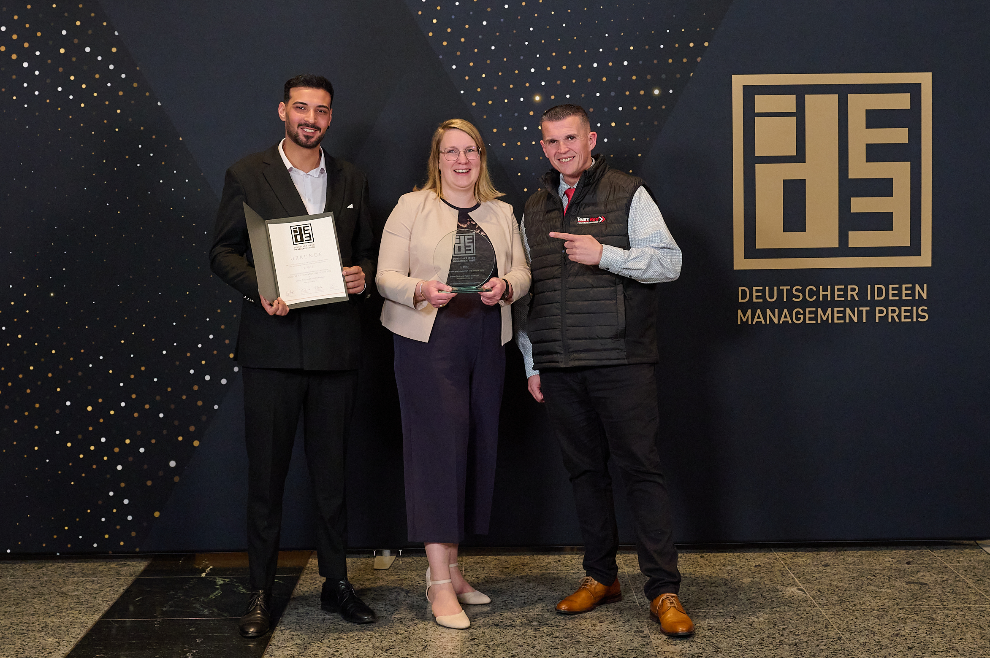 |  | 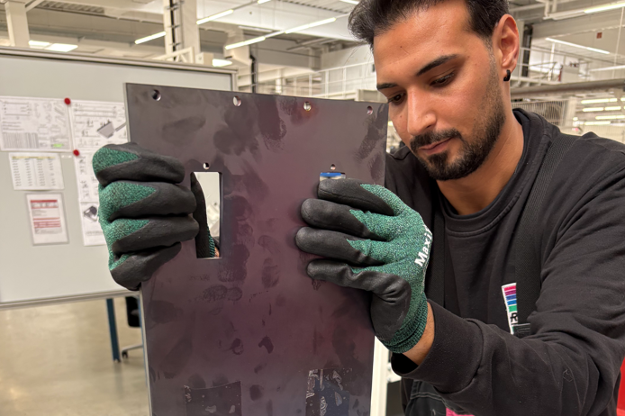
Image 1  What winners look like: at the awards ceremony in Stuttgart (from left to right), Samet Önlü, together with Nora Groth from Rittal’s Idea Management team and Mario Milic, Head of Work Planning, accepted the “German Idea Management Award 2026”. |  |  | Image 2  “There has to be a better and more sustainable way of doing this”: Samet Önlü’s suggestion for improvement saves Rittal €120,000 a year in costs, waste, and rework.

May be reproduced free of charge. Please name Rittal GmbH & Co. KG as the source.

Rittal

Rittal is a leading global supplier of enclosure systems, automation and infrastructure with its industrial, IT, energy and power, cooling and service units. Rittal products and solutions are used in over 90% of global industries – standardised, customised, and always of the very best quality.
Our approach and methodology: Rittal, Rittal Software Systems (Eplan and Cideon) and Rittal Automation Systems (RAS, Ehrt and Alfra) combine their hardware and software expertise to streamline, optimise and digitalise processes across the entire value chain for our customers including their IT infrastructure – from control and switchgear construction, machine building to factory operators or the energy sector.
Our delivery promise: Rittal standard products are delivered in Germany within 24 hours, and within 48 hours throughout Europe.
Customer focus
Improving efficiency and increasing productivity through automation and digitalisation is one of the biggest challenges for our customers. This requires in-depth knowledge and expertise, the combination of hardware and software, and cross-sector networking. We are convinced that creating and connecting data rooms is crucial to the success of industrial transformation. And that is exactly our speciality and field of competence.
Eplan and Rittal are driving the development of the digital automation twin, making data accessible and useable in operations as well. Cideon is improving data consistency in the digital product twin context with its CAD/CAM, PDM/PLM and product configuration expertise. German Edge Cloud’s ONCITE Digital Production System (DPS) makes production process data transparent, enabling it to be optimised – right through to energy management using digital production twins.
Sustainability
Environmental and climate protection, social commitment and ethical corporate management are a given for Rittal. We take our responsibility for a sustainable future seriously. Our approach to resource management and conservation involves continuous improvement of our own production processes and ensuring that our products have the lowest possible Product Carbon Footprint. Our solutions support our customers in achieving their own climate targets.
Family business and global player
Founded in 1961, Rittal is the largest company in the owner-operated Friedhelm Loh Group. The group operates worldwide, with more than 13 production sites and over 95 international subsidiaries. It has more than 12,600 employees and posted revenues of 3 billion euros in fiscal year 2023. In 2023, the Friedhelm Loh Group was presented with the “Best Place to Learn” and “Employer of the Future” awards. In 2025, Rittal was awarded the Top 100 Seal as one of Germany’s most innovative medium-sized companies for the third time in a row. In 2025, the Rittal plant in Haiger won overall first place in the independent and highly-prestigious “Factory of the Year” competition, which recognised it as a hallmark of manufacturing excellence and one of the very best factories in Europe.

For more information, visit www.rittal.com and www.friedhelm-loh-group.com.

Corporate & Brand Communications

Hans Robert Koch Steffen Maltzan
Phone.: +49 2772/505-2693 Phone: +49 2772 505 2680
Mail: koch.hr@rittal.de Mail: maltzan.s@rittal.de

Rittal GmbH & Co. KG, Auf dem Stützelberg, 35745 Herborn, Germany

