Friedhelm Loh Group donates to charitable and aid organisations
Friedhelm Loh Group employees and owner support social projects with a €200,000 donation
Haiger, 04/03/2026
A community’s strength becomes especially apparent when it comes to helping other people. The Friedhelm Loh Group’s traditional annual donation, with which employees and owner Professor Friedhelm Loh jointly support social projects, also makes this evident. An impressive sum of €200,000 was collected and will now help no less than twelve social institutions and aid organisations.
The donations have been made to a total of twelve social institutions in the regions where the company is located, as well as to international organisations: The Bethel Stiftung, the Caritas workshops in Westerwald-Rhein-Lahn, the Christian Hospice Service in Görlitz, Regional Diakonie in Dillenburg and Limburg, Evenzkreis Mühlacker / Wiernsheim, Global Aid Network (GAiN) in Gießen, Bethanien Diakonissen-Foundation Lerchenweg Monheim, JUMPERS Gera, Lebenshilfe Altenkirchen, Tafel Hesse, Oberlausitzer Kinderhilfe Bautzen, and the Debora Foundation India. The Rittal Foundation, the Friedhelm Loh Group’s charitable foundation, handed over the donations in January.
Greater educational opportunities for people with disabilities
For example, the donation will allow the Caritas workshops in Westerwald-Rhein-Lahn to continue developing their educational programme for people with disabilities: Thanks to an earlier donation from the Friedhelm Loh Group, licences for an AI supported video tool were purchased and have now been prolonged for a further two years. “Thanks to the donation, we can continue to create customised, professionally designed, explanatory videos. This modern form of learning strengthens digital inclusion, supports vocational training and helps our employees understand, repeat and retain content more easily,” says Managing Director Armin Gutwald.
A day of recreation and encounters on the Rhine
Thanks to the donation, Lebenshilfe Altenkirchen has organised a boat trip on the Rhine for 121 participants. “This annual outing has become an integral part of Lebenshilfe Altenkirchen’s calendar of events. The families of those with intellectual disabilities from all areas and facilities of Lebenshilfe in the Altenkirchen district take part. The point of the day is to facilitate dialogue, strengthen the sense of community and reinforce the feeling of togetherness,” explains Managing Director Michael Blachut. The donation also enabled the purchase of a fully automatic coffee machine for the new “Haus Weitblick” residential home in Flammersfeld.
Supporting the construction of a school clinic in Nigeria
The donation also has an international impact: The Global Aid Network (GAiN) organisation, based in Giessen, is using the money to build a school clinic on the premises of the Baobab Education Centre in Nigeria. The clinic is intended to benefit the families of the pupils, who are often unable to afford a journey to the nearest town or to pay for medication or treatment. “No child should ever have to die of malaria or diarrhoea. Construction can start soon,” explains Tabitha Funck from GAiN. A kindergarten, a primary, and a secondary school are already present on the grounds of the education centre that the organisation supports. The site is surrounded by fields where the schoolchildren’s parents grow crops in an agricultural cooperative, thereby improving their own economic situation.

Taking responsibility out of conviction
Helping people in an uncomplicated and effective way, giving them the courage to live their lives, and alleviating suffering are what motivate the annual fundraising campaign, for which, in 2025, Professor Friedhelm Loh again topped up the sum given by his employees to €200,000. “It is anything but a matter of course that you have donated and made a valuable contribution to people who are not only dependent on help due to hard times, but who also acutely need our assistance,” Professor Friedhelm Loh thanked the donors from within his group of companies. “With your donation, you’ve shown solidarity and a sense of responsibility towards your community. Thank you very much indeed!”

Tackling need by working together – in our home region, at company locations and abroad – has been a matter close to the heart of Friedhelm Loh Group ever since its founding in 1961. When Rittal celebrated its 50th anniversary in 2011, owner Professor Loh established the Rittal Foundation, which officially began funding in 2012. In the meantime, the Rittal Foundation and the Friedhelm Loh Group – with employees and management representatives operating hand in hand – have raised more than ten million euros to support good causes.

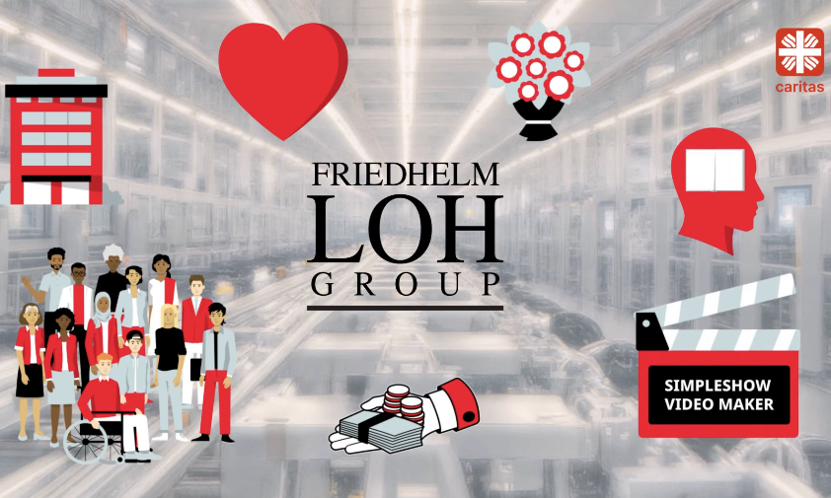 |  | 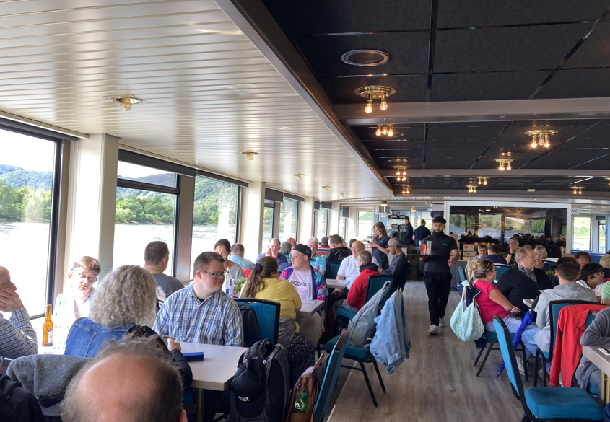
Image 1  Screenshot from an AI-generated “thank-you” video: The Caritas workshops in Westerwald-Rhein-Lahn can specifically develop their training programme for people with disabilities. |  | Image 2  A day of relaxation, encounters and shared experiences: Thanks to the donation, people with intellectual disabilities and their families were able to take part in a very special cruise on the river Rhine.

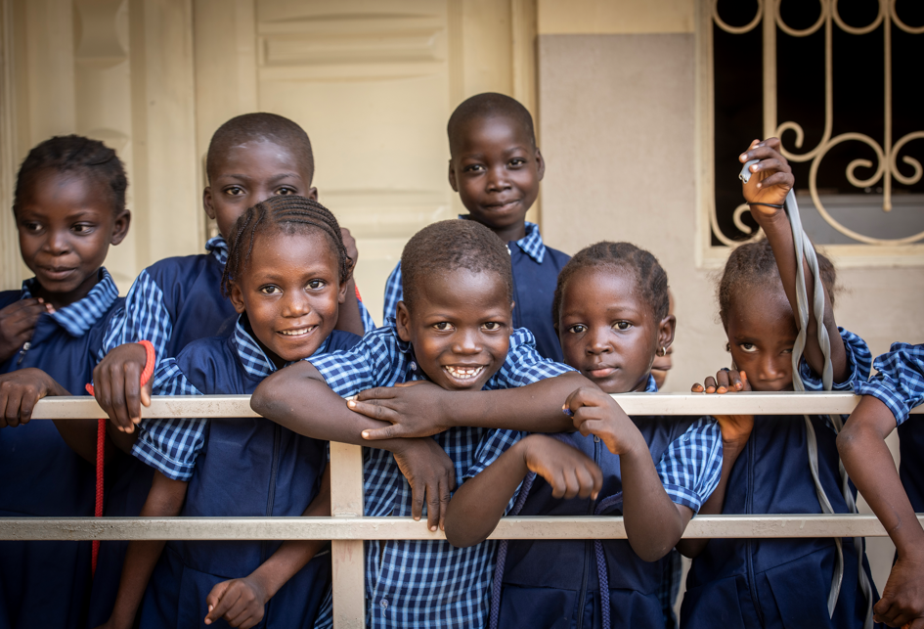
Image 3
Children from the Baobab Education Centre in Nigeria. In addition to a kindergarten and a school, a clinic for the health of pupils and families from the neighbourhood is also set to be built here.

May be reproduced free of charge. Please cite Friedhelm Loh Group as source and Caritas (image 1), Carina Hoffmann (image 2) and Claudia Dewald (image 3) as picture source.

Friedhelm Loh Group

The companies of the globally successful Friedhelm Loh Group invent, develop and produce innovative system solutions for industry, IT and energy, as well as other important sectors worldwide. They are among the top addresses in their respective industries.
With their combined hardware and software expertise, Rittal, Rittal Software Systems (Eplan and Cideon) and Rittal Automation Systems (RAS, Ehrt, Alfra) optimize, digitize and automate processes along the entire customer value chain, including the IT infrastructure – from panel building and switchgear manufacturing to mechanical engineering, factory operators and the energy sector. Stahlo and LKH round off the portfolio with end-to-end manufacturing expertise in the modern materials of steel and plastic.
The Group is internationally successful, with 13 production sites and 95 subsidiaries. The family-owned company employs 12,100 people and generated a turnover of 3 billion euros in 2024. In 2023, the Friedhelm Loh Group was recognized as a “Best Place to Learn” and “Employer of the Future.
For more information, visit www.friedhelm-loh-group.com.

Corporate Communications
Hans-Robert Koch Friedhelm Loh Group
Corporate & Brand Communications Rudolf-Loh-Straße 1
Phone.: 02772/505-2693 35708 Haiger
koch.hr@rittal.de www.friedhelm-loh-group.com

