Rittal awarded the seal of approval for innovative strength again in 2026
Rittal ranked among the top 100 innovators five times in a row
Herborn, 2026-02-13.
In 2026, Rittal GmbH & Co KG is again one of Germany’s most innovative SMEs. The prestigious “Top 100” award goes to the company from the Friedhelm Loh Group for the fifth time in a row. Rittal is making a bold statement, showing that sustainable innovation is a key factor in successful entrepreneurship.
The Top 100 competition, now in its 33rd year, has examined how innovation-oriented medium-sized companies are and how they act accordingly. Rittal ranked in the largest class for the fifth consecutive time, demonstrating its strength above all in the “Innovation Processes and Organisation” category.
Evidence-based selection process with five different categories
How much working time does management reserve for the topic of innovation? How many innovative ideas do employees raise? The TOP 100 data-based selection process revolves around such questions. In detail, innovation researcher Professor Nikolaus Franke and his team examine five categories: innovation-promoting top management, innovation climate, innovation processes and organisation, external orientation/open innovation, and innovation success. The basis for this is an online questionnaire filled in beforehand by the companies involved. The five categories are reflected in more than 100 test criteria. “At TOP 100, we thoroughly analyse just how innovation-oriented the applicants are. And those who are exceptional receive confirmation of this by receiving the TOP 100 seal,” says Professor Nikolaus Franke.

Rittal as an driver of innovations for future-oriented manufacturing companies
“Rittal has long aspired to be an innovation leader for future-proof industry.” Together with our sister companies Eplan and Rittal Automation Systems (RAS), Rittal is accelerating industrial automation, promoting digitalisation, and increasing both its own efficiency and that of our customers," says Uwe Scharf, Rittal’s Managing Director Sales Germany and Europe.

Since being founded in 1961, Rittal has stood for the courage to change. What began with the standardisation of enclosures is now a global systems enterprise with strong software expertise. The early investment in Eplan over 40 years ago was a milestone: It laid the foundation for consistent, data-driven processes in industry. Now, this data, supplemented by AI, represents the key to the next level of industrial automation.

Speed is of essence
In panel building and switchgear manufacturing, Rittal, Eplan and RAS are accelerating the entire process chain with consistent data – from planning and designing to production with equipment and systems, through to operation. With industry expertise and advanced technology, the companies are thus increasing their customers’ competitiveness.

“Customers all over the world are benefiting from our innovative strength and solutions because we help them speed up work processes, save precious resources and have a competitive edge,” says Mario De Marco, Rittal CSO. “It’s great that the Top 100 position confirms this.”

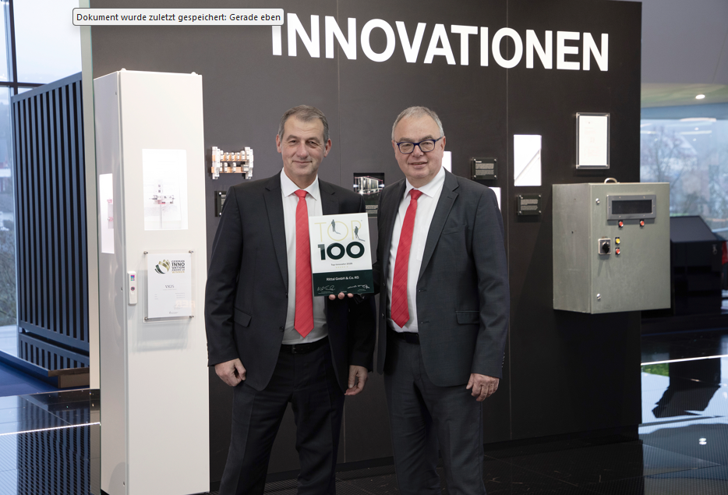 |  | 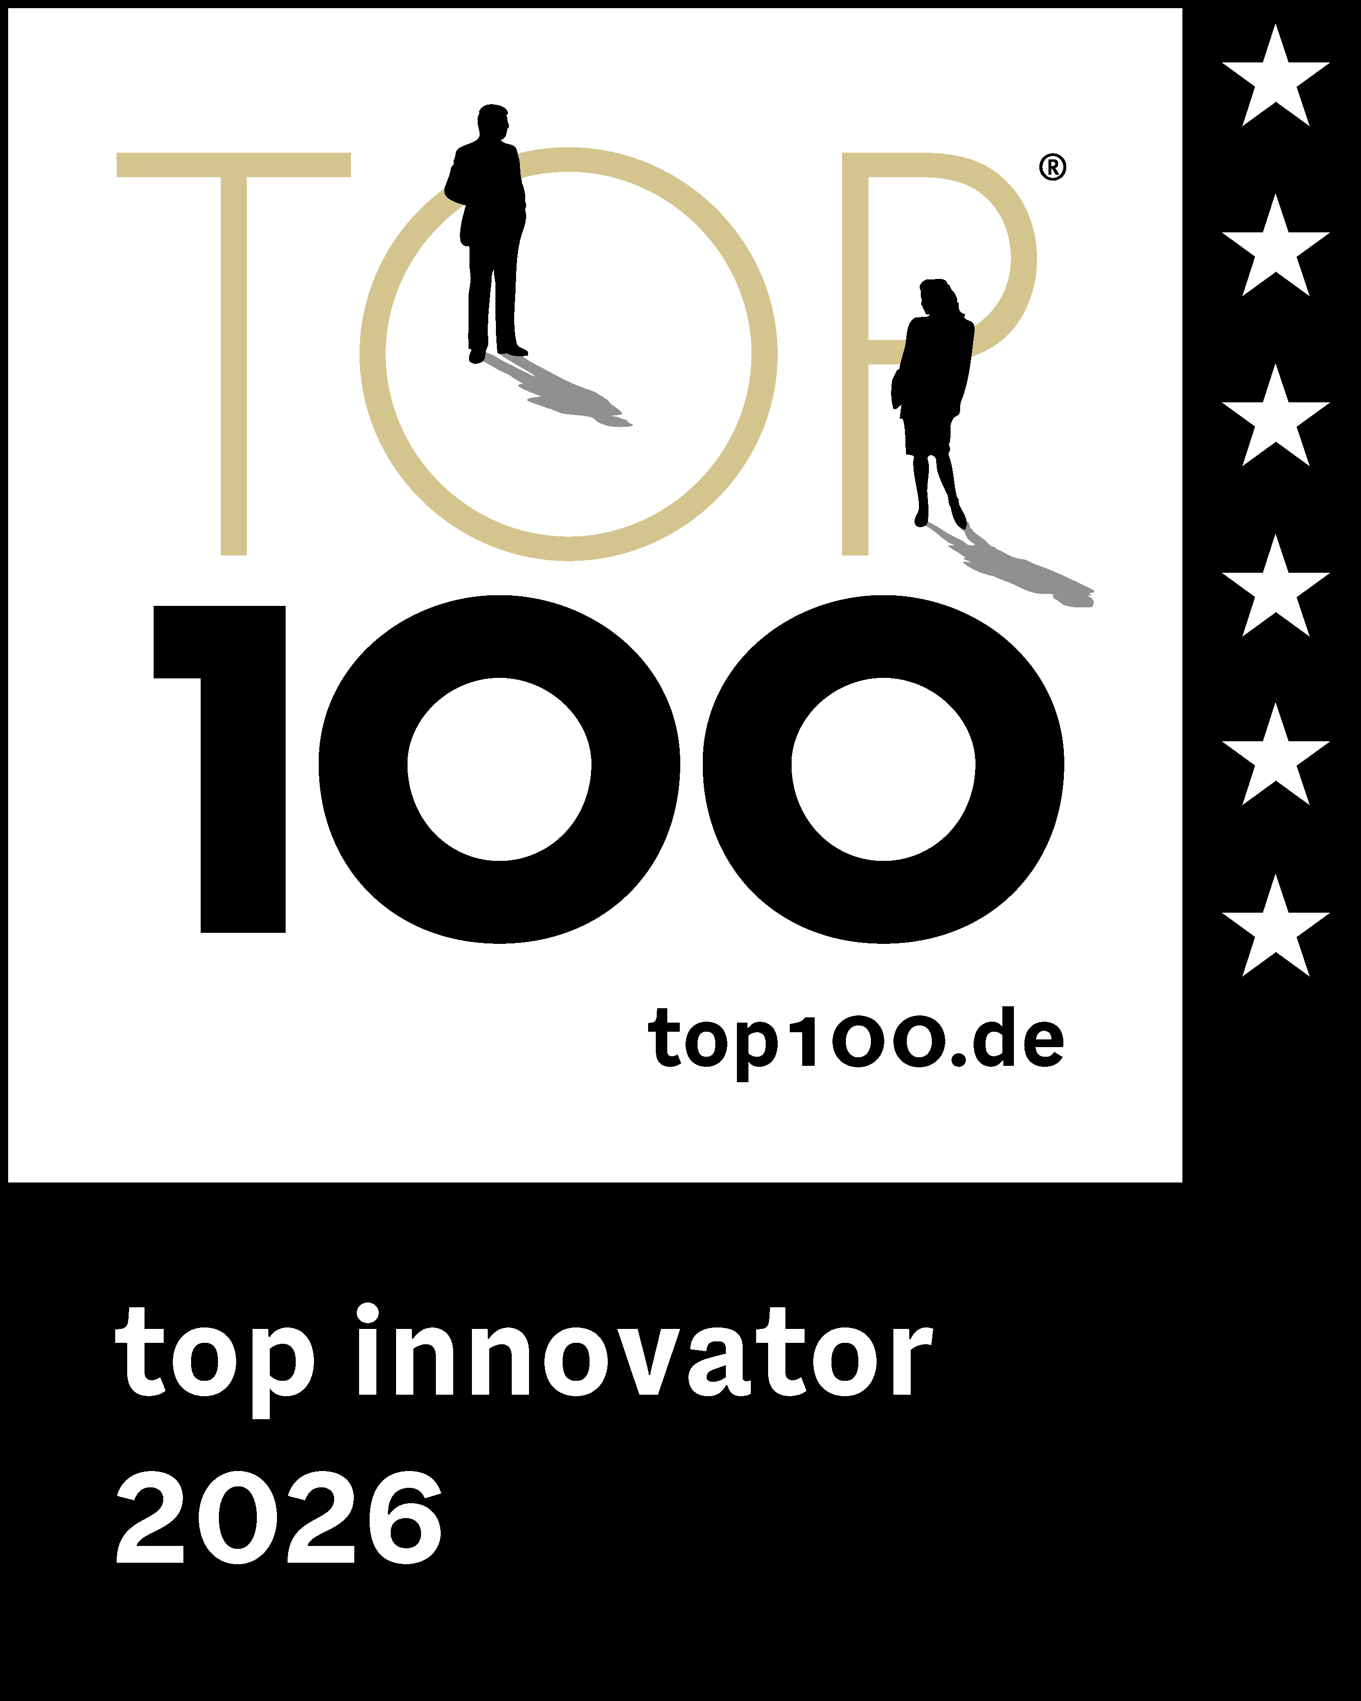
Image 1  Managing directors Mario De Marco (left) and Uwe Scharf with the “Top 100” award: “Customers all over the world are benefiting from our innovative strength and solutions.” |  | Image 2  Rittal has been awarded the Top 100 seal for the fifth time in row and is once again one of Germany’s most innovative medium-sized companies.

May be reproduced free of charge. Please name Rittal GmbH & Co. KG as the source

Rittal

Rittal is a leading global supplier of enclosure systems, automation and infrastructure with its industrial, IT, energy and power, cooling and service units. Rittal products and solutions are used in over 90% of global industries – standardised, customised, and always of the very best quality.

Our approach and methodology: Rittal, Rittal Software Systems (Eplan, Cideon) and Rittal Automation Systems (RAS, Ehrt, Alfra) combine their hardware and software expertise to streamline, optimise and industiralise processes across the entire value chain of their customers including their IT infrastructure – from control and switchgear construction, machine building to manufacturing companies or the energy sector.

Our delivery promise: Rittal standard products are delivered in Germany within 24 hours, and within 48 hours throughout Europe.
Focus on the customer
Improving efficiency and increasing productivity through automation and digitalisation is one of the biggest challenges for our customers. This requires in-depth knowledge and expertise, the combination of hardware and software, and cross-sector networking. We are convinced that creating and connecting data rooms is crucial to the success of industrial transformation. And that is exactly our speciality and field of competence.

Eplan and Rittal are driving the development of the digital automation twin, making data accessible and useable in operations as well. Cideon is improving data consistency in the digital product twin context with its CAD/CAM, PDM/PLM and product configuration expertise.
Sustainability
Environmental and climate protection, social commitment and ethical corporate management are a given for Rittal. We take our responsibility for a sustainable future seriously. Our approach to resource management and conservation involves continuous improvement of our own production processes and ensuring that our products have the lowest possible Product Carbon Footprint. Our solutions support our customers in achieving their own climate targets.
Family business and global player
Founded in 1961, Rittal is the largest company in the owner-operated Friedhelm Loh Group. The group operates worldwide, with 13 production sites and 95 international subsidiaries. It has 12,600 employees and posted revenues of 3.1 billion euros in fiscal 2024. In 2023, the Friedhelm Loh Group was presented with the “Best Place to Learn” and “Employer of the Future” awards. In 2026, Rittal was awarded the Top 100 Seal as one of Germany’s most innovative medium-sized companies for the fifth time in a row.

For more information, visit www.rittal.com and www.friedhelm-loh-group.com.

Corporate Communications
Hans-Robert Koch Rittal GmbH & Co. KG
Corporate & Brand Communications Auf dem Stützelberg
Phone: +49 (0)2772/505-2693 35745 Herborn, Germany
koch.hr@rittal.de www.rittal.com

